
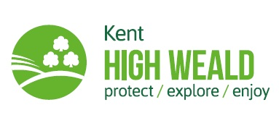

Kent County Council –
KENT HIGH WEALD COUNTRYSIDE PARTNERSHIP

Job Description: Volunteer Trainee Conservation Officer
Directorate: | Growth, Environment and Transport
Unit/Section: | Kent High Weald Countryside Partnership
Grade: | N/A (Voluntary; budget for travel and training)
Responsible to: | KHWP Manager

Application Form

Please cross reference with the job description to complete this application form.

A) Your details:

Name:

Address:

Postcode:

Phone:

Email:

B) Experience and training:
Please give details of any current experience or training which may be relevant to this role (you can expand on this in section E):

C) Qualifications:
Please give details:

Da) Employment history: Your current or most recent employer:

Name of employer:

Address:

Postcode:

Job title:

Length of time with employer:

Reason for leaving:

Duties:

b) Previous employers:
Please tell us about other jobs you have done and about the skills you used or learned in those jobs.

E) Supporting statement:
Please tell us why you are applying for this job and why you think you are the best person for the job. Please include your current interests and aspirations.

F) Interview arrangements and availability:
If you have a disability, please tell us if there are any reasonable adjustments we can make to help you in your application or with our recruitment process.

G) When can you start working for us?

H) Right to work in the UK:
Do you need a work permit to work in the UK? Yes / No

References:
Please give the names and contact details of 2 people who we can ask to give you a reference. We may ask them before an offer is made. If possible, please make one reference your current employer (if applicable) and one a personal contact.

Referee 1:
Name and Contact Details:

Referee 2:
Name and Contact Details:

J) Declaration:
I confirm that to the best of my knowledge the information I have provided on this form is correct and I accept that providing deliberately false information could result in my dismissal.

Name:

Signature:

Date:

Please return this application form to cally.fiddimore@kent.gov.uk
Closing date for applications is Midday Friday 29th August 2025
Interview Date is proposed as Tuesday 9th September 2025.

